**Capturing Complete Palm Prints in Connecticut**

The National Palm Print System (NPPS) facilitates the storage of known palm prints and the search of latent palm prints left at crime scenes.  Currently, the NPPS repository maintains tens of millions of unique palm print identities and individual palm prints tied to those identities, all of which are available for investigative leads.

Palm prints are a trusted, valuable tool that law enforcement can use to identify suspects. NPPS estimates that 30 percent of latent prints found at crime scenes come from the palm. The palm, which is a larger hand area than fingertips, has more characteristics for Latent Examiners to compare and match than fingerprints. While fingerprints usually have about 150 definable characteristics for identification, a palm print can have about 1,500. Nearly all states, some territories, and the District of Columbia submit palm print images to NPPS. The value of palm prints is evident from the numerous success stories from using them that participating agencies report.

Unfortunately, NPPS cannot enroll and process all the palm prints that agencies submit. A significant number of states have enrollment success rates under 80 percent due to low quality or incomplete images, and some have success rates under 50 percent. Your state is one of the states that has a palm print enrollment rate of 96.98 percent over the last six months.

Palm prints that fail enrollment can never be searched against latent records in the Unsolved Latent File (ULF). This can result in a failure to identify potential suspects, which may cause crimes to go unsolved.

**The main factor to improve palm print enrollment rates**

The most common reason for palm print enrollment failure is incomplete image capture. A complete, usable set of palm print images includes the whole inner surface of the hand, including the insides of the fingers. The set of palm prints should capture the impression of the center of the hand—which people commonly call the palm—plus the inside surface of the fingers out to the last joint. That last joint, which is called the distal area, features the fingerprints. Capturing the fingerprints along with the rest of the palm results in a complete set of print images that maximizes the chances of successful identification.

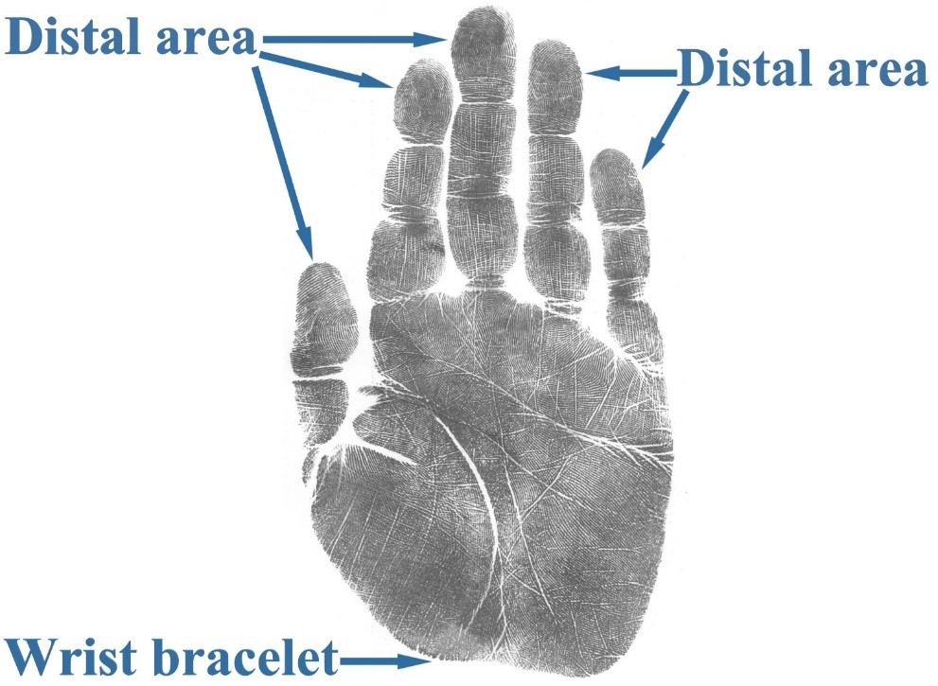

A complete palm print includes the wrist bracelet to the distal areas and all parts between.

The distal images are important for ensuring the correctness of the palm print and to ensure enrollment. This is because criminal history records in NGI are based on fingerprint identification, and the distal part of the fingers contains the fingerprints. If a palm print submission correctly includes the distal images, the system can check the fingerprints against the palm areas, ensuring they are part of the same hand. Without the distal images, the system cannot perform this check.

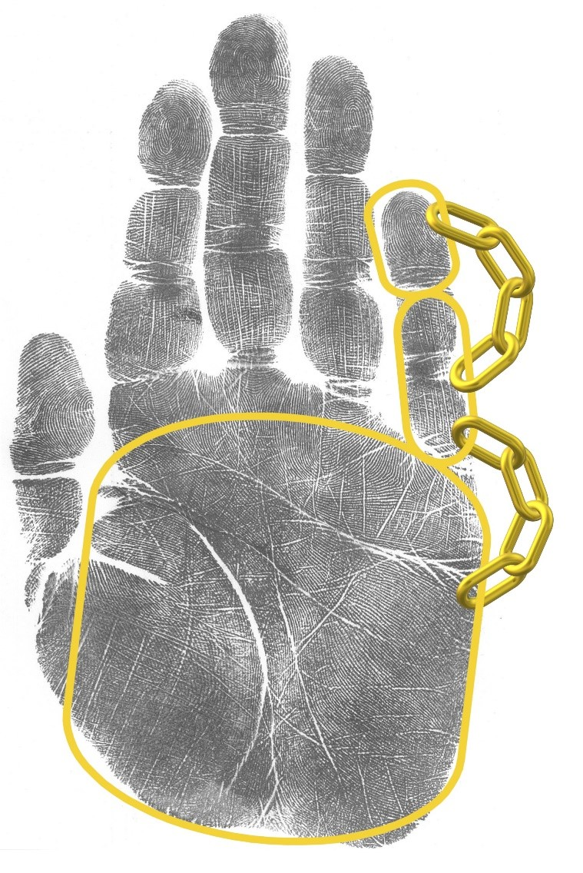

The NGI System uses the sections of a complete palm print submission to link the parts of the palm and the fingerprints together in a verified record.

The equipment that many agencies have may be unable to capture the entire palm print in a single image due to a small scanning surface that only prints portions of the submission at a time. The FBI urges those agencies to capture each portion of the palm print submission completely so the system can create a complete record from those portions. Agencies can consult and download the FBI’s “[Palm Print Capture](https://fbibiospecs.fbi.gov/file-repository/palm/palm_print_poster_v2-0-rev10012019.pdf/view)” poster for guidance on how to record a complete set of palm prints.

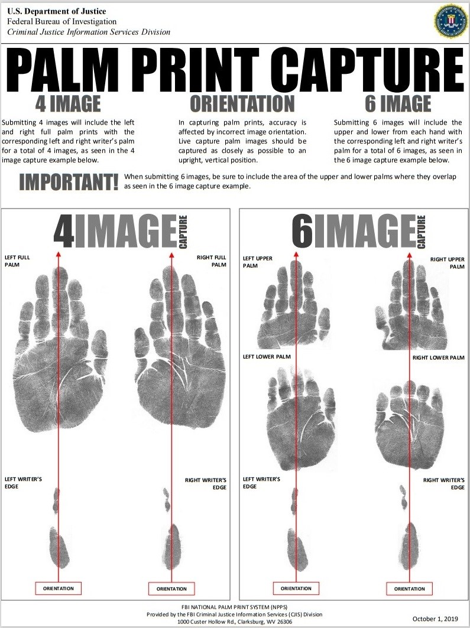

The “Palm Print Capture” poster shows how to record a 4- or 6-image palm print submission.

To support partner agencies and ensure NPPS has a gallery of high-quality palm prints, the FBI is proactively working with state submitting agencies to address any palm print enrollment issues the state may have. A palm print capture guide and references are available at <https://fbibiospecs.fbi.gov/biometric-modalities-1/palm> and <https://le.fbi.gov/science-and-lab/biometrics-and-fingerprints/biometrics/biometric-training>.  We encourage law enforcement agencies to contact the Palm Services and Analysis Team at 304-625-2849 or email: [palm_prints@fbi.gov.](mailto:palm_prints@fbi.gov)  FBI palm print subject matter experts are ready to help.